**Spectroscopic Pathology Pictorial Documentation**

Version 3, Feb 2023

## Purpose

The purpose of this document is to provide insight into the desired procedure to collect skin data using a spectroscopic probe. Images are provided to describe each step.

## Setup

The physical setup can be seen below. The stage moves in the x and y using manual fine control knobs. The stand moves in the z using manual knobs. The probe is placed in the stand and the sample is placed on the stage.

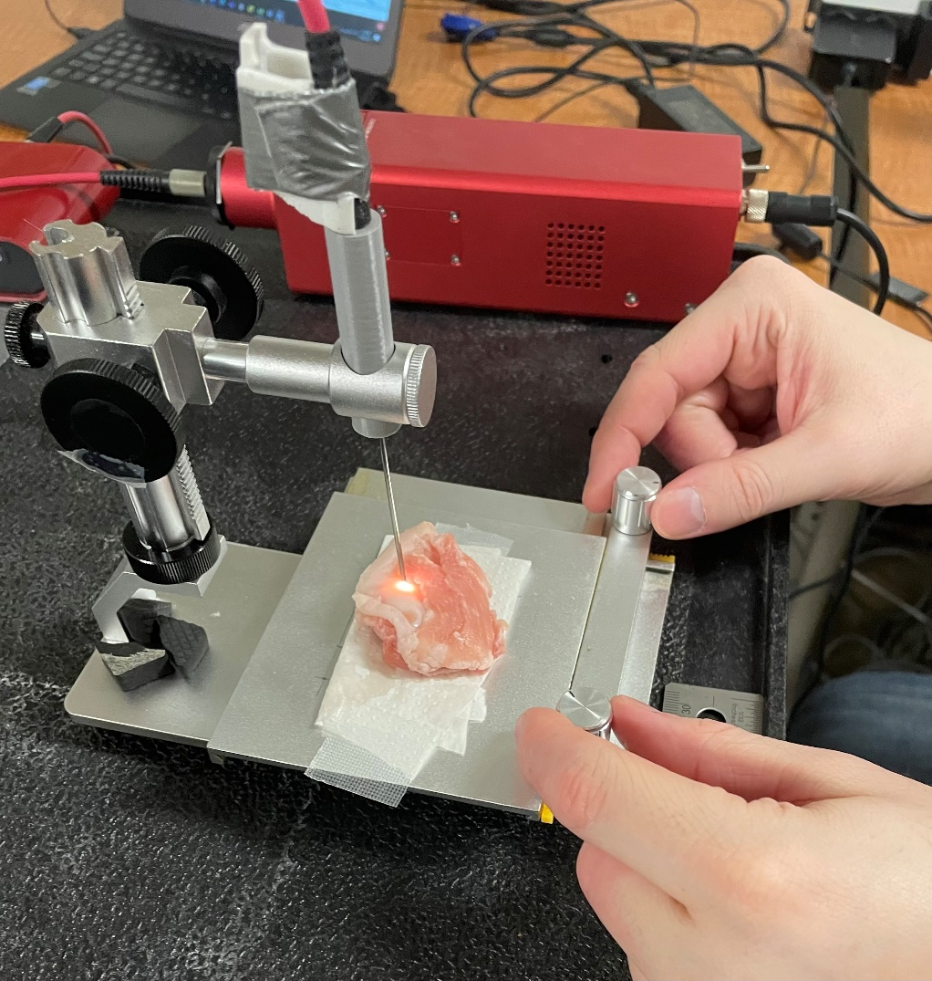

Probe

Stage

Stand

## Procedure

1. Tissue paper is placed in the centre of the stage

1. The skin specimen is place atop the tissue paper in the centre of the stage

1. Optical imaging (photography) of specimen. Please ensure the specimen and measurement references are full visible.

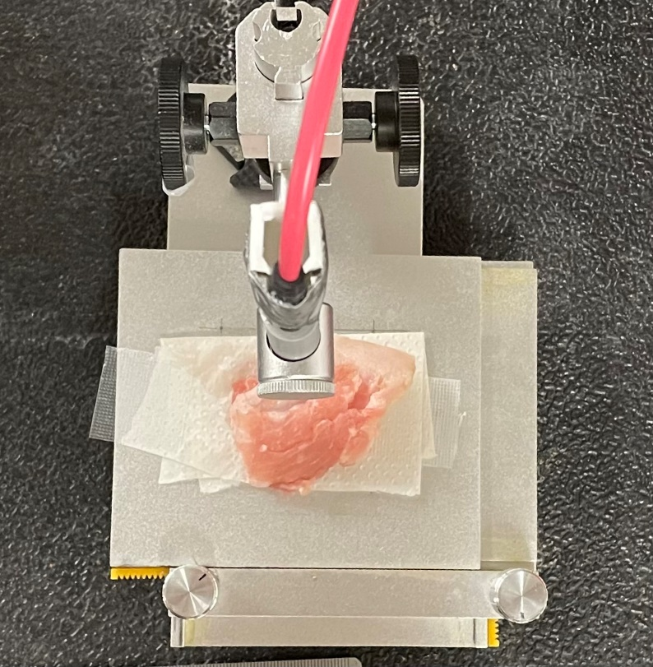

1. Position the region of interest (ROI) under the probe using the two knobs on the stage. The laser should directly illuminate the ROI.

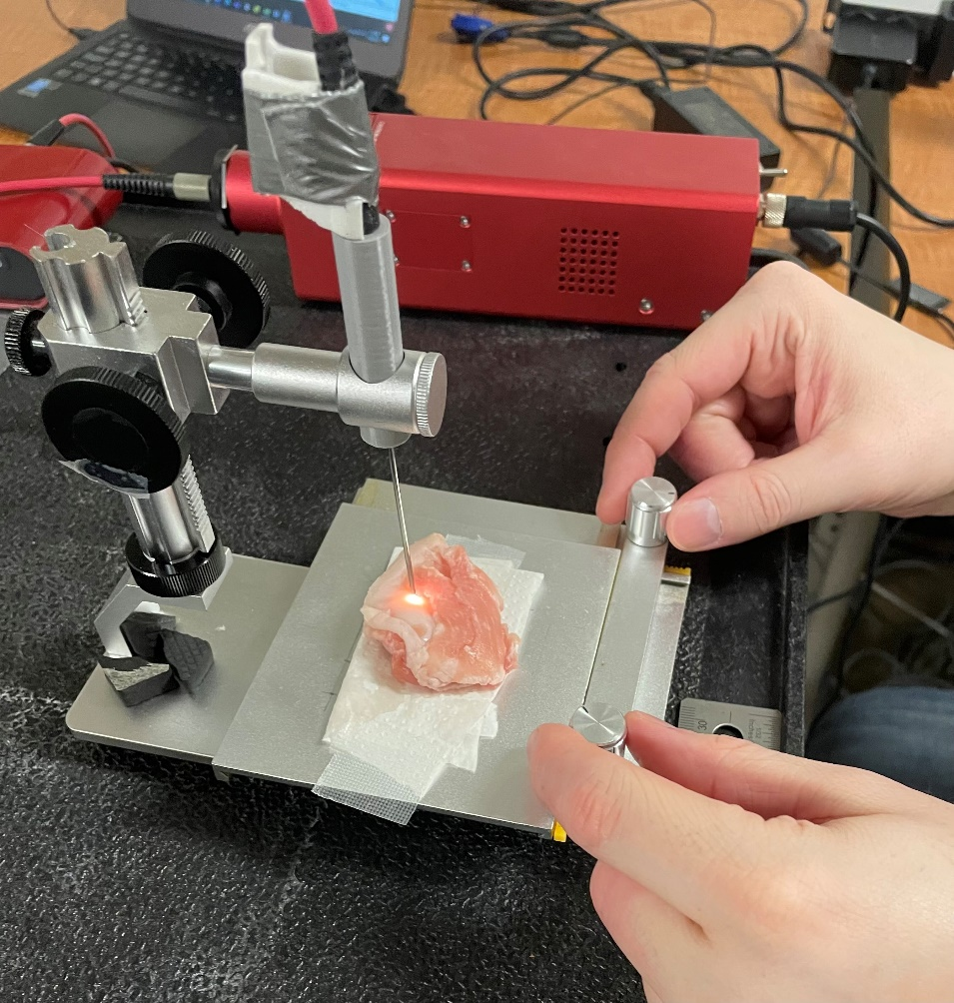

1. Once in position.
   1. Lower the probe until it is within 5mm of the tissue
      1. Closer = smaller collection area = cleaner readings.
      2. Closer = signal
      3. The probe should not touch the tissue surface.
   2. Tell the computer operator the tissue type. (Cancer, healthy)
   3. The operator will request the probe be lowered or raised to achieve

optimal signal strength.

1. Once confirmed the operator will record the region of interest for 1 second
   1. *Repeat steps 4-6 for all regions of interest*.

We will repeat steps 1 – 6 for each tissue sample.

**Spectroscopic Pathology: Full Documentation**

Version 3, Feb 2023

## Purpose

The purpose of this document is to provide insight into the desired procedure to collect skin data using a spectroscopic probe. Images are provided to describe each step.

## Setup

The physical setup can be seen below. The stage moves in the x and y using manual fine control knobs. The stand moves in the z using manual knobs. The probe is placed in the stand and the sample is placed on the stage.

Material checklist

Physical



Probe

Stage

Stand

1. Plug in the light source (40 minute warm up time recommended)
2. Connect the spectrometer to the light source via the red optical cable
   1. Note the optical cable is unidirectional so ensure the “Light source” line is connected to the source and the other end to the spectrometer
3. Connect the spectrometer to the computer using the USB-A to Micro USB
4. Set up the stage and the stand in the above configuration
5. Place the optical probe vertically in the stand

Software

1. Start PLUS server
2. Open 3D slicer
3. Navigate to Spectroscopy -> Broadband Spectroscopy



1. Click connect button to initialize IGT connections



1. Select the root save location



## Procedure: For each patient

1. Select the Patient Label



## Procedure: For each sample

1. Place a clear plastic grid on the stage (or tissue paper)
2. Place the skin specimen in the centre of the stage
3. Optical imaging (photography) of specimen. Please ensure the specimen and grid are full visible.
4. Position the region of interest (ROI) under the probe. The laser should directly illuminate the ROI. Knobs can be used for fine tuning.

1. Once the doc has confirmed they are in position. Select the class under Data Collection, class selector. (Cancer, healthy)

1. Collect the data: either,
   1. If point measurement is desired, select required duration (seconds) and click ‘Collect Sample’.





* 1. If sample is large, click continuous scan to start a continuous recording. When the doc is done, stop the recordings.



Note:

* Point collection takes multiple readings per spatial location, increasing signal to noise ratio.
* Continuous collection is much quicker and is beneficial for larger samples.

1. Data is saved into path $./MmmDD/Patientx/Class$ and labeled with format $MmmDD_patientX_sample\#_label.csv$
2. **Clean up:** 
   1. Wipe down the plastic grid with a sterilizing wipe
   2. Or throw out and replace the tissue

## Packing up

1. Ensure all equipment touched by tissue has been cleaned
2. Unplug all equipment
3. Store equipment in labeled boxes for transportation